**WWI Soldier’s Equipment**



When a soldier went ‘over the top’ to attack the

enemy he had to carry all of this equipment through the mud, barbed wires and crater holes made by mines. They had to make sure that they did not get shot at the same time.

1. 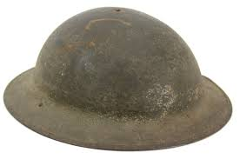**What do you think would be useful for a soldier to take into battle with him?**
2. **Why do you think a soldier would need to take all of this equipment with him and not leave it behind?**
3. **Estimate how much this would weigh.**
4. **Is there a better way for soldiers to go into battle?**