Weapons and Technology in World War I

In WWI, many technological advancements were made in order to gain an upper hand in warfare against the enemy.

The main weapon used by soldiers in the trenches was the bolt action rifle; the Ross Rifle or the Lee Enfield. 15 rounds could be fired in a minute and a person 1,400 meters away could be killed.
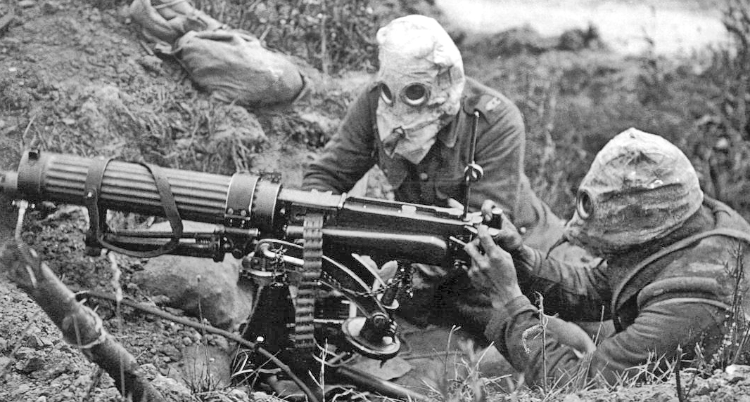
Machine Guns needed 4-6 men to work them and had to be on a flat surface. They had the fire-power of 100 guns. The British Vickers could be operated by two men, could fire between 450-600 rounds a minute and could be brought to the front line trenches.
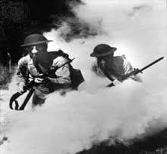
Large field guns (artillery) had a long range and could deliver devastating blows to the enemy but needed up to 12 men to work them. They fired shells which exploded on impact
GAS!!!!!!!
The German army were the first to use chlorine gas at the battle of Ypres in 1915. Chlorine gas causes a burning sensation in the throat and chest pains. Death is painful – you suffocate! The problem with chlorine gas is that the weather must be right.

Mustard gas was the most deadly weapon used. It was fired into the trenches in shells. It is colourless and takes 12 hours to take effect. Effects include – blistering skin, vomiting, sore eyes, internal and external bleeding. Death can take up to 5 weeks.

Tanks were used for the first time in the First World War. They were developed to cope with the conditions on the Western Front. The first tank was called ‘Little Willie’ and needed a crew of 3. Its maximum speed was 3mph and it could not cross trenches.

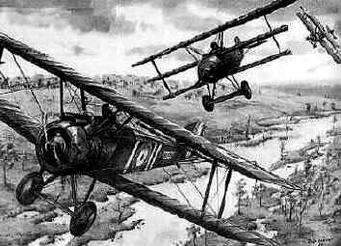
The more modern tank was not developed until just before the end of the war. It could carry 10 men, had a revolving turret and could reach 4mph.
Planes were also used for the first time. At first they were used to deliver bombs and for spying work but became fighter aircraft armed with machine guns, bombs and sometimes canons. Fights between two planes in the sky became known as ‘dogfights’.

Torpedoes were used by submarines. The Germans (and U-boats) used torpedoes to blow up ships carrying supplies from America to Britain.

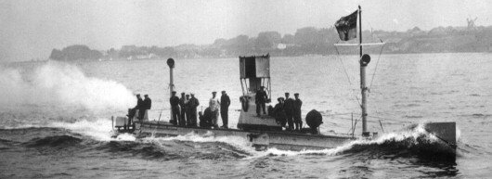
The Germans torpedoed the passenger liner Lusitania on May 1st 1915 which sank with a loss of 1,195 lives. Americans were outraged and joined the war in 1917 on the side of the allies.

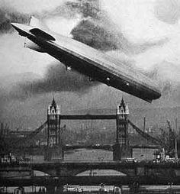

The Zeppelin, also known as blimp, was an airship that was used during the early part of the war in bombing raids by the Germans. They carried machine guns and bombs. However, they were abandoned because they were easy to shoot out of the sky.

The Good, the Bad, and the Ugly…
In the chart below, record positive and negative qualities for each item listed.

Weapon/tech | Positive | Negative
Rifles; Ross Rifle, Lee Enfield
Machine and Field Guns; Lewis Light, Vickers
GAS!; Chlorine and Mustard
Tanks
Planes
Torpedoes and Submarines; U-boats
Zeppelin

