United Nations Organizations

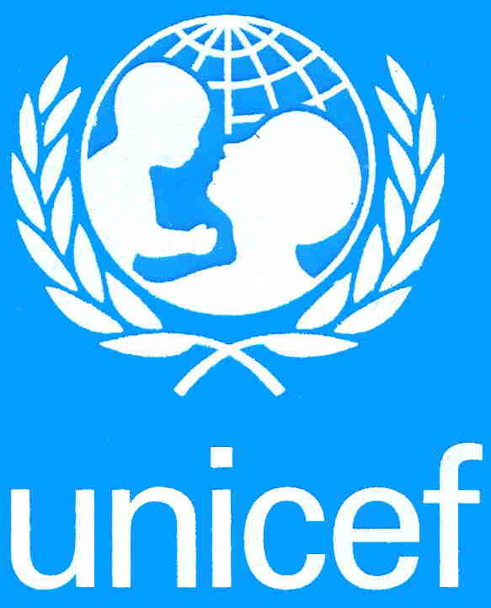

UNICEF (United Nations Children's Fund) was created to work with others to overcome the obstacles that poverty, violence, disease and discrimination place in a child’s path. They believe that They can, together, advance the cause of humanity.

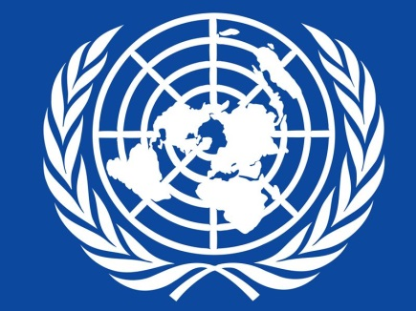
UNDP (United Nations Development Programme) is the UN's global development network, an organization advocating for change and connecting countries to knowledge, experience and resources to help people build a better life. They are on the ground in 166 countries, working with them on their own solutions to global and national development challenges. As they develop local capacity, they draw on the people of UNDP and Their wide range of partners.

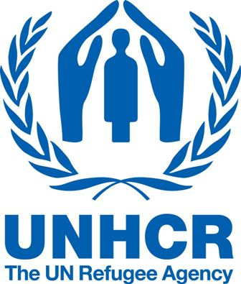

UNHCR (United Nations High Commissioner on Refugees) - The agency is mandated to lead and co-ordinate international action to protect refugees and resolve refugee problems worldwide. Its primary purpose
is to safeguard the rights and well-being of refugees.

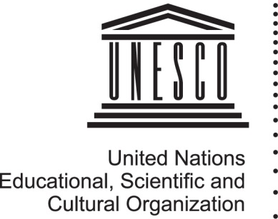
UNESCO’s (United Nations Educational, Scientific and Cultural Organization) mission is to contribute to the building of peace, the eradication of poverty, sustainable development and intercultural dialogue through education, the sciences, culture, communication and information. The Millennium Development Goals (MDGs) – underpin all UNESCO’s strategies and activities.

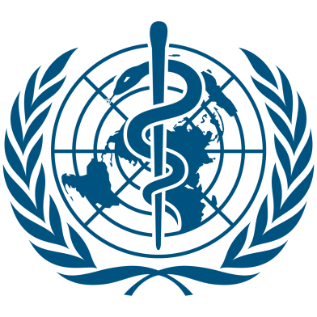

World Health Organization (WHO) - The directing and coordinating authority for health within the United Nations system. World Trade Organization (WTO) - deals with the rules of trade between nations at a global or near-global level.

- Why do you think these 5 organizations are important?

- Brainstorm, with a partner, a situation or event happening in the world where each one of these organizations would be useful. (There are 5 therefor you must come up with 5 answers, one for each organization)

- Which of the 5 organizations do you think is the most important and why?

- Read the attached article UNICEF Canada launches urgent appeal as escalating Ebola crisis puts 10 million children at risk and construct a properly formatted 9 sentence paragraph on why you think Canada should or should not get involved. (Think global action, involvement and support as important or not important to sustain solid global relations and world health)
__________________________________________________________________________________________________________________________________________________________________________________________________________________________________________________________________________________________________________________________________________________________________________________________________________________________________________________________________________________________________________________________________________________________________________________________________________________________________________________________________________________________________________________________________________________________________________________________________________________________________________________________________________________________________________________________________________________________________________________________________________________________________________________________________________________________________________________________________________________________________________________________________________________

UNICEF Canada launches urgent appeal as escalating Ebola crisis puts 10 million children at risk
Publish Date:
09/23/14
Photos and video from Ebola-affected countries can be downloaded from: http://uni.cf/1xZAb39
TORONTO, September 23, 2014 - Today, UNICEF Canada is launching an urgent appeal for donations to respond to the Ebola outbreak that is ravaging West Africa and putting 10 million children at risk. The humanitarian organization says it needs more than $200 million to respond, but has only raised $25 million to date, amid heightened concerns about the rapidly escalating crisis.
"Ebola is spreading more quickly than we ever could have imagined and is outpacing global efforts to combat it. It's hard for us to imagine as Canadians what it's like to be in these countries where a fatal disease is spreading like wildfire. Luckily for most of us, our understanding of this kind of crisis is only what we've seen in movies. But for millions of children and families in West Africa, it's a stark reality," says David Morley, President and CEO of UNICEF Canada.
"I can't stress how urgent the need is. New cases are reported every day—and tens of thousands of new cases are expected in the coming months. Whole communities are at stake. Canadians are among the most generous people in the world when humanitarian crises hit and we're urging them to continue this legacy by donating to help children affected by Ebola."
Ebola stats and facts:
- This Ebola outbreak has claimed more than 2,600 lives and devastated communities in Guinea, Liberia and Sierra Leone where an estimated 10 million children and youth under 20 years old live in Ebola-affected areas. Of them, 2.5 million are under the age of five.
- The outbreak is spreading fast with 47 per cent of the total number of cases seen within the past 21 days.
- Guinea, Liberia, Nigeria, Senegal, and Sierra Leone, have reported 4,963 cases and 2,453 deaths (as of 16 September).
- Women have been disproportionately affected by the virus because of their role as caregivers, comprising nearly 75 per cent of all cases so far.
Other risks:
- Lack of protection for health workers, challenges in providing protective supplies to families and monitoring burials, misconceptions and social unrest, have contributed to the spread of the virus.
- In contrast to previous outbreaks, this outbreak has reached urban centres and has been transmitted across international borders.
- The potential longer term impact of this crisis – on trade, economic growth, education, employment, social services – can be minimized if affected countries are not isolated.
- The breakdown of services to prevent epidemics - such as immunization, provision of clean water and sanitation and provision of bed nets - increases the risk of outbreaks of measles, cholera and malaria as well as resurgence in polio. This would in turn seriously damage the response efforts against Ebola and lead to a significant number of deaths amongst children and their families.

UNICEF's response:
- Providing social mobilization and information in affected countries, playing a critical role to support, mobilize and incentivize networks of community health workers and volunteers.
- Airlifting essential supplies to the affected countries on a massive scale for use in treatment and care centres as well as for continuity of basic services. By early October, UNICEF will have delivered 1300 metric tonnes (MT) on 55 flights.
- Planning support for water supply, sanitation, and solid waste disposal and hygiene standards in care centres, alongside support for health standards.
- Working closely with the governments in providing alternative means of learning for children affected by the closure of schools.
- Providing counselling for children and families severely affected by the outbreak, including orphaned children and widows.
- In the neighbouring countries at risk (Mali, Senegal, Guinea Bissau and Ivory Coast), UNICEF is working with the governments and partners to create awareness among the communities, while emergency supplies and medical equipment are being delivered for preparedness.

