Canadian History ~ CHC2P Web Quest

Learning Goal: To gain an understanding of life in the trenches and Trench Warfare in WWI while refining my research skills.
Use the internet and links from www.nealsclassroom.weebly.com to help you complete the following vocabulary, questions and diagram.

- What is “trench deadlock” and what caused it?

- Describe a possible attack.

- What was “no-man’s land”? Describe what a soldier could expect when entering “no-man’s land”.

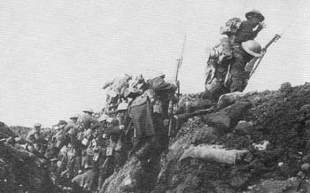
- What do you thing is meant by the phrase “over the top”?

- Describe trench construction and layout.

- What is trench foot and why would soldiers get this?

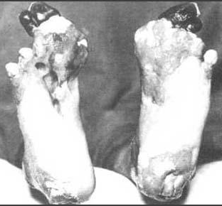

- Describe the “Morning Hate”.

- What did the soldiers do to deal with their boredom?

- What was the food like for soldiers?

- Describe the pest infestations in the trenches (rats, lice, etc.):

- What do you think is the most horrible aspect of being in the trenches?

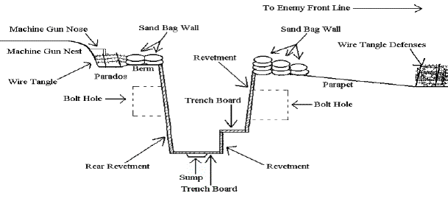
Label this trench diagram!

