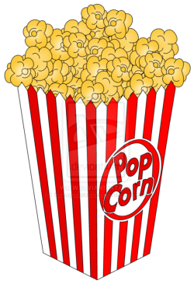
To Kill a Mockingbird Popcorn
Name (you get no choice on this!) | Popcorn Name (choose from your cup!)  Explain the relation between the listed character and the one you have drawn. | Symbol (choose from your cup!)  Explain the relation between the listed character and the symbol you have drawn.
Scout

Jem

Atticus

