Those Pesky Homophones!
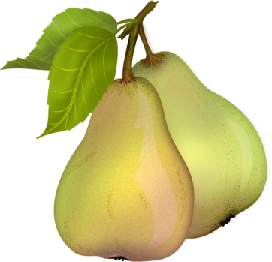
Definition: each of two or more words having the same pronunciation but different meanings, origins, or spelling, e.g., new and knew.

Ex: “To” can also be ____________ and ___________.

Your turn! This is a race! Complete this chart to show you are the master of homophones! You may work in pears…or do I mean pairs?

Feet |  | See
Knit |  | Red
Need |  | Pour
Heal |  | Rain
Raise |  | Roe
Greece |  | Toe
Blue |  | Hair
Pail |  | Where
Bread |  | Bow
Ring |  | Meet
Main |  | Wait
Pair |  | Made
I |  | Weather
Nose |  | Wry
Been |  | Hour
Stare |  | Bear
Beat |  | Flower

Can you think of more homophones? List any below:

