The Road to War
Once Hitler gained power in Germany, he began to prepare for war. He violated the Treaty of Versailles, annexed various countries and created a formidable military. The Allies stood and watched with the hope that another war would not start.
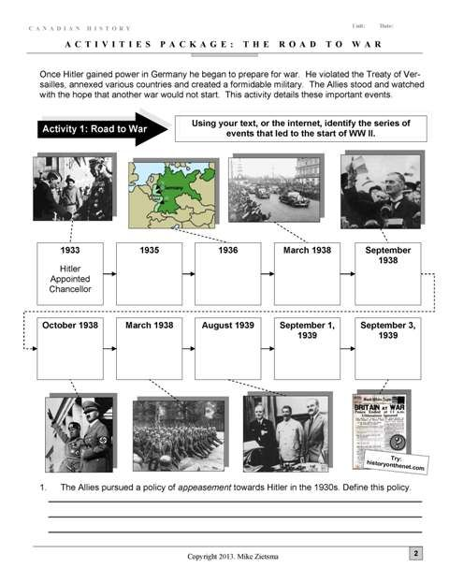
Using your text, or the internet, identify the series of
event that led to the start of WWII

The Allies pursues a policy of appeasement towards Hitler in the 1930s. Define this policy.
______________________________________________________________________________________________________________________________________________________________________________________________________________________________________________________________________________________________________

