The Rise of Hitler
January 1933 – Hitler became _______________________
The depression after the Wall Street Crash made many more people vote for the Nazis. In 1933 Von Papen convinced ______________________ that Hitler should become Chancellor.

February 1933 – The ___________________ ____________
The Reichstag building burnt down.
A ____________________ was found inside the building. He admitted _________________.
Chancellor Hitler was able to convince people that the Communists were trying to take power by ____________________.
HITLER CAN
RULE ALONE
FOR FOUR
YEARS. THERE
IS NO NEED TO
CONSULT THE
REICHSTAG.
He was able to have the Communists banned from the Reichstag.

March 1933 – The _____________________ ___________
The enabling act gave Hitler the power to make his own laws. So, he ____________________ all other _________________ ____________!

June 1934 – The _____________________________________________
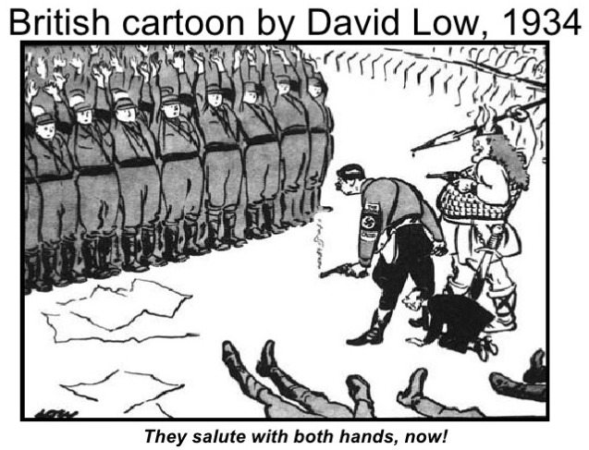
Hitler had to get rid of Rohm. He was too much of a _______________.
- On the night of 30th June 1934 Hitler’s S.S. killed over 1000 SA members including Rohm.
- The army were pleased.
- Hitler had gained the support of the army.

August 1934 – The Death of ___________________ ___________________
President Hindenburg’s death gave Hitler the opportunity to _______________ the role of chancellor and ________________. He called himself ‘____________ _________________’.
Every soldier swore a personal __________________________ to ADOLF HITLER.
Hitler Youth
The Hitler Youth (Hitler Jugend, HJ) was the organizing of youth with the purpose of raising a future generation of loyal Nazi’s. It was formed in 1926, and by 1939 over ______ of German children were involved.

__________________________: This was mandatory to continue in the HJ and school. Up to 4 hours a day was spent on boxing or gymnastics.

___________________: History was rewritten to promote Nazism and the good of the state. Anything opposing Nazi ideals was taught as a ___________.

____________________: It was taught as a way to devalue the Treaty of Versailles. Also an excuse to teach “__________________” – Which means “____________________________”.

__________________: Used to justify classifications, racist policies and population control. Superiority was the essence of these teachings.

