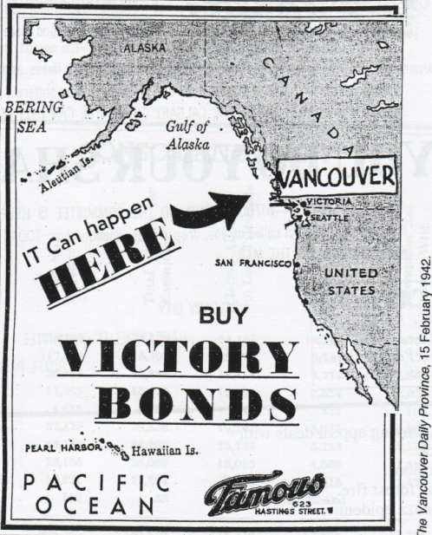
The Internment of Japanese Canadians

Canada declared war on Japan shortly after the attack on Pearl Harbor. Japanese Canadians were unfairly suspected of being spies as many were fisherman. The property of the Japanese-Canadians (land, business etc.) were confiscated by the government and sold and the proceeds were used to pay for their internment. Conditions were poor, men were forced into labor. Those unwilling to live in internment camps faced the possibility of deportation to Japan.
Notice from the federal government
To Male Enemy Aliens
- All male Enemy Aliens of the ages of 18 years to 45 years, inclusive, shall leave the protected area herin before referred to on or before 1st day of April, 1942.
- That, subject to the provisions of paragraph No.1 of this Order, no Enemy Alien shall, after the date of this order, enter, leave or return to such protected area except with the permission of the Commissioner of the RCMP Force, or an Officer of that Force designated by the Commissioner to act for him in this respect;
- That no Enemy Alien shall leave in his possession or use, while in such protected area, any camera, radio transmitter, radio shortwave receiving set, firearm, ammunition, or explosive.

On February 24, 1942, the order in (1) was extended to include all persons of Japanese heritage, and the order in (3) was extended again to authorize the RCMP to search without warrant, enforce a dusk-to-dawn curfew, and confiscate automobiles, radios, cameras, and firearms. S.T. Wood (Commissioner), RCMP, Ottawa, Feb. 7, 1942, Order-in-Council PC 365 (Jan. 16, 1942).

“…the thought occurs that there is far more possibility of trouble developing against the Japanese in Canada as a result of agitation at present being carried on by certain individuals, than there would be by the Japanese against this country. I feel that the present agitation being carried on by Alderman Halford Wilson [of Vancouver, BC] is provocative and in times such as these downright dangerous if it is allowed to go on unchecked.” Source: Memorandum from Assistant Cmmissioner, RCMP F.J. Mead, August 21, 1940.

“I think the Japanese here should be treated exactly as our people are treated in Japan – they should be interned. It is definitely a practicable scheme. Others can do it, why can’t we…? In the East they don’t understand our problem here; they’ve never had it themselves.” Birt Showler, Vancouver Daily Province, 1942.

“I was in that camp for four years. When it got cold the temperature went down to as much as 60 below. The buildings stood on flat land beside a lake. We lived in huts with no insulation. Even if we had the stove burning the inside of the windows would all be frosted up and white.” Hideo Kukubo, Vancouver: The Japanese Canadian Centennial Project, 1978).
“I stand here tonight to plead with you, not for myself alone, but for all of us. …But more than the return of lost property, reparation is the outward symbol acknowledging the loss of our rights. Time heals the details, but time cannot heal the fundamental wrong. … As long as restitution is not made, that knowledge will last throughout the generations to come …that a house, a home, was lost through injustice. It is important for you to remember that the loss of this property spelled the last indignity for a people deprived of the right to move freely, to live where they choose, to be what they can be best, deprived of participation in the life and events of their country, native or adopted, and deprived most of all of their integrity. To that end, to be a great nation, Canada must destroy the virus of rot that affects our national life and among other vices, race prejudice ranks high.” Muriel Kitigawa, This is My Own (1941-48)
