The Cold War Continued…Canada’s Involvement
Collective Security
Many countries formed alliances due to fear of nuclear war:
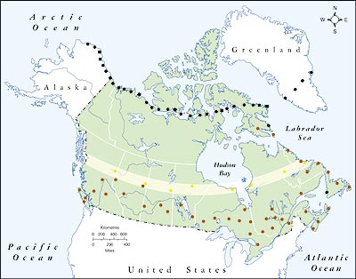
  - UN – formed after WWII to prevent wars…
  - NATO – U.S., Canada, GB, France formed to protect against Soviet expansion
  - NORAD – U.S., Canada to protect against Soviet attack
  - Warsaw Pact – USSR, other communist countries

How were Canadians affected by the Cold War?
  - cancelled Avro Arrow in favour of the Bomarc B missile
  - attack-warning systems (radar) setup across Canada: Canadian radar stations - DEW Line; Mid-Canada Line, Pine tree Network
  - created ‘what to do’ pamphlets and video (ex. Duck and Cover)
  - established Civil Defence College for adults and teens
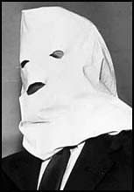
  - fought with the U.S.A. in the Korean War
Canada was rocked by spy scandal in 1947
- Igor Gouzenko (Soviet Spy) stole secret documents from Ottawa
- He wanted to ‘defect’ (leave the USSR for good), but needed protection – RCMP reluctantly agreed
- Exposed Stalin’s efforts to steal nuclear secrets, and many of his ’sleeper agents’ Significance? Launched the Cold War for the general public…

On the Brink of Nuclear War
In October, 1962, U.S. discovers Soviet nuke’s in Cuba
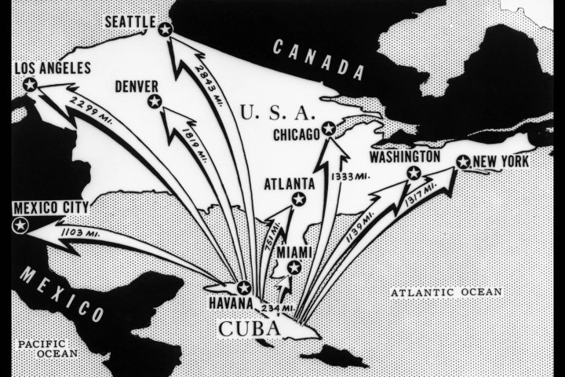
- Huge threat! Could reach as far as Canada from there…
- U.S. threatens war if Soviets don’t take them back
- Naval blockade to stop ships from bringing more…world prepares for war!
- Diefenbaker refuses to put Canada on full alert – upset U.S. president Kennedy
- Soviet’s gave in – crisis averted

How did it End?

