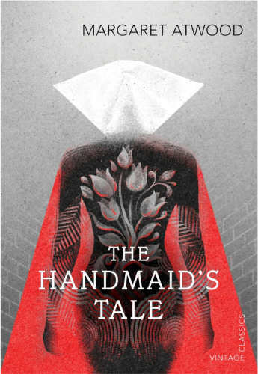
The Ceremony, Satire, and Atwood’s “Modest Proposal”
Satire Revisited:
  - Satire is a style of rhetoric that exposes vices and foolishness in people and society.
  - Satire generally uses humor, irony, sarcasm, and other techniques to get an emotional reaction from the audience.
  - Satire often aims to create political or social change.

Johnathan Swift A Modest Proposal
“I have been assured by a very knowing American of my acquaintance in London that a young healthy child well nursed is at a year old a most delicious, nourishing, and wholesome food.” (10)
[…] although I rather recommend buying the children alive and dressing them hot from the knife, as we do roasting pigs. (16)
Discuss what kind of reaction you think this would provoke in a reader from 1729? What kind of reaction do you think this would provoke in a reader from 2016? 2050?
Swift expresses a chilling lack of empathy. He provides the reader with a great deal of gory details. Do you think this is necessary for him to convey his message? Is this necessary for a satire?

The Handmaid’s Tale as a “modest proposal”
Revisit Atwood’s epigraph. How important do you think each quote is now? Keep in mind that the biblical epigraph echoes the scene before the ceremony.
Your Turn… Draft a modest proposal of your own. What part of society will it reflect? How might you convince the reader to believe in your issue? What will their reaction be?

