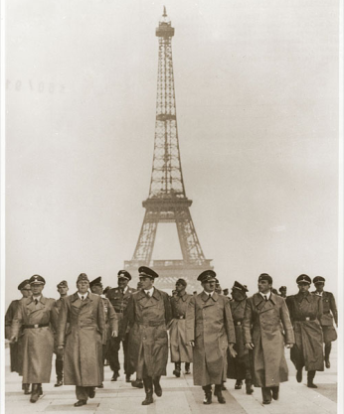
The Battle of Britain and the Blitzkrieg
Sept 1939 – Germany’s crushing take-over:
Poland was taken in 1 month
The ________________ War (Winter 1940) when no _____________ took place
Spring 1940 - Crushed:
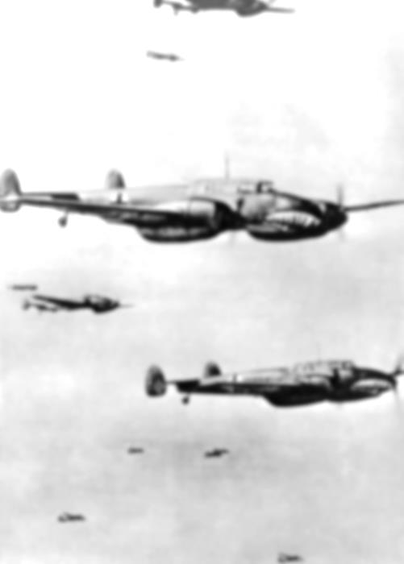
Denmark - ____day, Norway - _______days, The Netherlands – _____ days, Belgium – _______ days , France – _______ weeks

The Fall of France
The Nazis occupied France in June of 1940, the next plan was to invade _______________. The Defence of Britain depended on the ______________________ and the ________________________ Force (RAF). Hitler needed to clear the English __________________ before even considering an invasion of England.

Blitzkrieg – Operation Sea Lion
THE PLAN - Air attack using Luftwaffe to;
  - Take out ________________ sites
  - Create ________________ in civilian population
  - Paratroopers secure strategic sites
Then….Armored ___________________ – break through into towns (create an entry ‘column’). Infantry attack (troops arrive in truck loads – enter after tanks THEN City ___________________

Problems for the Nazis
The Luftwaffe were not yet designed for ____________ _______________ _____________.
Britain also had an early ______________ _____________ that allowed them to detect and track aircraft.

Phase 1: The Channel
Phase 1 began in July and lasted until mid-August with Germany attacking _________________________ in the English Channel. During this phase, both sides began to lose _______________ and _______________. Replacing both would be difficult for Britain and Germany, but Britain had help.
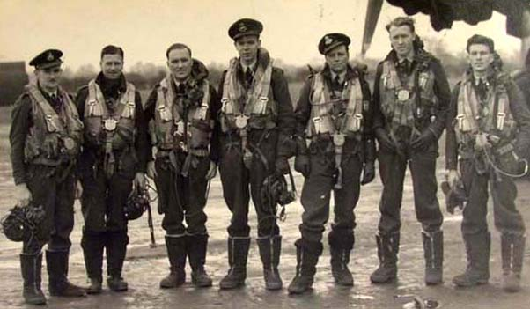
Canadian Assistance
Canadian businessman ___________________________ organized massive _____________________________.
Beaverbrook was able to keep the RAF supplied with planes to replace heavy loss suffered by the British.
The RAF also lost many skilled pilots (only had 3000 to start)

Canada and Their Pilots
Nearly 15% of RAF pilots during the Battle of Britain were __________________. Also, pilots and air crew were being trained in Canada. Canadian assistance in these areas proved to be invaluable to Britain.

Phase 2: The Eagle
In August the Germans began attacks on _____________________________ and ___________________.
By early September the Germans seemed to be winning but Hitler’s impatience caused him to change his strategy.

Phase 3: The Blitz
In this phase Germany began to attack ___________. On September 7, 1940; ________ German ________ attacked London. Hitler’s hope was that the public would pressure the British gov’t to ________________.

Knowing Where to Bomb
Targeting London was easy – pilots simply had to follow the River _________ which took them straight to the important St. Katherine’s Docks in the East End. The first bombers dropped__________________ (fire bombs) to ________________________ for the following explosives bombers.

Defending Britain
This was a tough challenge – Britain had no night time fighters. ____________ and the newly discovered ___________ helped as an _______________________________. Anti-Aircraft guns and _____________ ____________________ were the only obstacles facing the Luftwaffe.
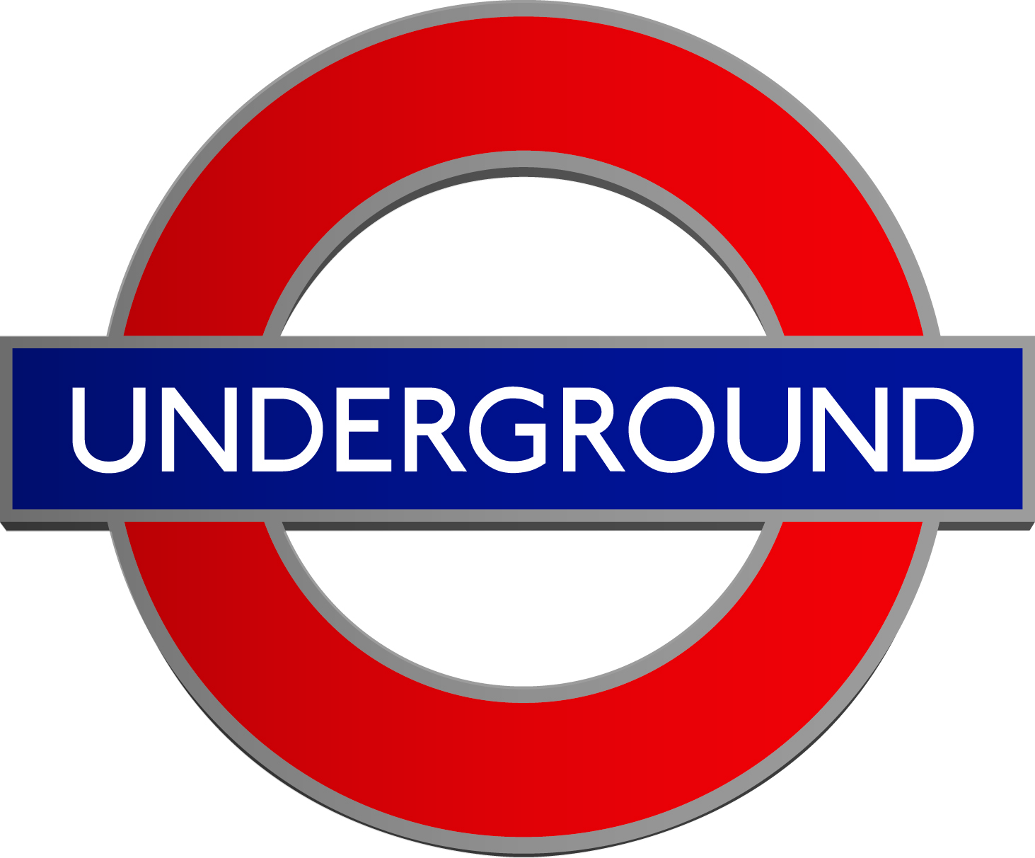
Britain’s Response
The British responded by ___________________ thousands of people from London into the ____________, including 6000 children sent to _______________. Each day the British would awake to rebuild their cities rather than surrender. 1000’s of people slept in shelters and even the Underground! (London’s subway system)

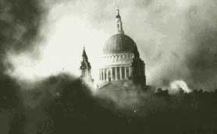
How Were People Effected
People found whole streets had gone. Rescue efforts saved people from rubble. 1000s of people were made homeless.

The Battle of Britain Ends - FOR THE FIRST TIME, HITLER DID NOT WIN.
By September 12th the threat of an invasion passed because the weather and sea conditions were not favourable to a large scale invasion. Although the bombing continued, Germany was left with a weakened Luftwaffe and Britain still would not surrender!
What new technology allowed Britain to succeed? List all you can think of!

