1989: Massacre in Tiananmen Square
http://news.bbc.co.uk/

Several hundred civilians have been shot dead by the Chinese army during a bloody military operation to crush a democratic protest in Peking's (Beijing) Tiananmen Square.
Tanks rumbled through the capital's streets late on 3 June as the army moved into the square from several directions, randomly firing on unarmed protesters.
The injured were rushed to hospital on bicycle rickshaws by frantic residents shocked by the army's sudden and extreme response to the peaceful mass protest.
Demonstrators, mainly students, had occupied the square for seven weeks, refusing to move until their demands for democratic reform were met. The protests began with a march by students in memory of former party leader Hu Yaobang, who had died a week before. But as the days passed, millions of people from all walks of life joined in, angered by widespread corruption and calling for democracy.
The June 3rd military offensive came after several failed attempts to persuade the protesters to leave.
Throughout the day the government warned it would do whatever it saw necessary to clamp down on what it described as "social chaos". But even though violence was expected, the ferocity of the attack took many by surprise, bringing condemnation from around the world.
US President George Bush said he deeply deplored the use of force, and UK Prime Minister Margaret Thatcher said she was "shocked and appalled by the shootings".
Facts:
Tiananmen Square is located in the center of Beijing, the capital of China.
Tiananmen means "gate of heavenly peace."
In 1989, after several weeks of demonstrations, Chinese troops entered Tiananmen Square on June 4 and fired on civilians.
Estimates of the death toll range from several hundred to thousands.
It has been estimated that as many as 10,000 people were arrested during and after the protests.
Several dozen people have been executed for their parts in the demonstrations.
Amid the panic and confusion students could be heard shouting "fascists stop killing," and "down with the government".
At a nearby children's hospital operating theatres were filled with casualties with gunshot wounds, many of them local residents who were not taking part in the protests.
Early in the morning at least 30 more were killed in two volleys of gunfire, which came without warning. Terrified crowds fled, leaving bodies in the road.
Meanwhile reports have emerged of troops searching the main Peking university campus for ringleaders, beating and killing those they suspect of co-ordinating the protests.

Timeline:
April 15, 1989 - Hu Yaobang, a former Communist Party leader, dies. Hu had worked to move China toward a more open political system and had become a symbol of democratic reform.
April 18, 1989 - Thousands of mourning students march through the capital to Tiananmen Square, calling for a more democratic government. In the weeks that follow, thousands of people join the students in the square to protest against China's Communist rulers.
May 13, 1989 - More than 100 students begin a hunger strike in Tiananmen Square. The number increases to several thousand over the next few days.
May 19, 1989 - A rally at Tiananmen Square draws an estimated 1.2 million people. General Secretary of the Chinese Communist Party, Zhao Ziyang, appears at the rally and pleads for an end to the demonstrations.
May 19, 1989 - Premier Li Peng imposes martial law.
June 1, 1989 - China halts live American news telecasts in Beijing, including CNN. Also reporters are prohibited from photographing or videotaping any of the demonstrations or Chinese troops.
June 2, 1989 - A reported 100,000 people attend a concert in Tiananmen Square by singer Hou Dejian, in support of the demonstrators.
June 4, 1989 - At about 1 a.m. Chinese troops reach Tiananmen Square. Throughout the day, Chinese troops fire on civilians and students, ending the demonstrations. An official death toll has never been released.
June 5, 1989 - An unidentified man stands alone in the street, blocking a column of Chinese tanks. He remains there for several minutes before being pulled away by onlookers.
June 5, 1999 - Approximately 70,000 people in Hong Kong take part in a memorial vigil.
February 2006 - Former journalist Yu Dongyue is released from prison after serving 17 years. He was arrested during the Tiananmen Square protests for throwing paint at a portrait of Mao Zedong.
June 4, 2009 - Tens of thousands of people commemorate the 20th anniversary of Tiananmen Square at a gathering in Hong Kong. In Beijing, journalists are barred from the square while the government blocks foreign news sites and Twitter.
April 2011 - The National Museum of China in Tiananmen Square is newly renovated and open to the public. The building contains no exhibits mentioning the events of June 1989.
2012 - Wuer Kaixi, one of the organizers of the Tiananmen Square protest, attempts to return to China by turning himself over to the Chinese embassy in Washington, DC. The embassy does not answer the door.

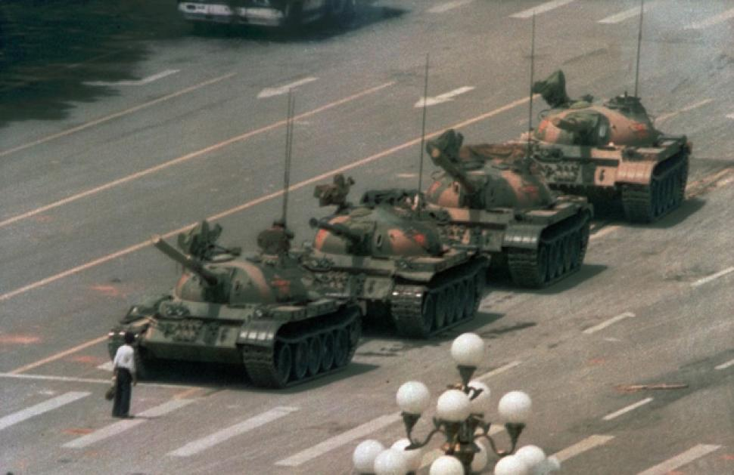
‘Tank Man’ stood tall in Tiananmen Square — yet remains unidentified more than 20 years later
Helen Kennedy – Daily News

A Chinese man stands alone to block a line of tanks heading east on Beijing's Cangan Blvd. in Tiananmen Square on June 5, 1989. The man has never been identified. Jeff Widener/AP

It’s been 23 years, and the world still doesn’t know his name.
When the skinny, slope-shouldered guy in a white shirt and black pants holding two plastic grocery bags, stepped in front of a column of government tanks rolling near the uprising in Tiananmen Square, he stepped into history.
The mystery man immediately became “Tank Man,” a powerful symbol of non-violent resistance. The photo became the one of history’s most vivid depictions of an individual taking on the power of the state.
BBC video of the moment showed the man’s simple bravery as he stood his ground in the middle of Beijing’s Chang'an Avenue as more than a dozen tanks came rolling towards him, then shuddered to a stop when he refused to move.
Looking tiny next to the hulking tanks, the man swung one of his shopping bags up and over in a “shoo” gesture.When the lead tank lumbered right to go around him, Tank Man darted right. When it went left, he went left.
After a brief standoff, Tank Man climbed onto the machine and appeared to be trying to talk to the men inside.
Then two men came running up and dragged him away.
The iconic image, smuggled out of China under the noses of officials who destroyed photographers’ film, appeared on the front page of newspapers around the world — everywhere but in China, where it was happening.
The drama took place during the mass student-run demonstrations for economic reform and political freedom that erupted in April 1989. Protests took place all over China, but the heart of the movement was in Beijing’s enormous Tiananamen Square.

