Symbol | Character’s name | Explanation
The conch
Piggy’s glasses
The Fire
The lord of the flies
The parachutist
The shelters
Painted faces
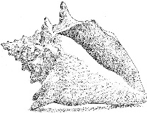
Lord of the Flies - Symbol Character Sort

