Quest Review #2: Global Citizenship

Complete this review and you will be exceptionally well prepared to write your test!
Part A:
- List all NGOs discussed in class and be able to explain their purpose and identify their logos.
- Which organization is the closest thing we have to a world parliament?
- Explain what globalization is by discussing the pros and cons of it.
- Why has there been a major shift of political and economic power from governments to corporations?
- How can youth have a positive impact on their communities?
- What can public leaders do to put an end to gender inequality?
- What can the media do to stop promoting specific gender guidelines/stereotypes?

Part B:
- Convention  - Convention of the Rights of the Child  - Declaration  - Globalization | - International Court of Justice  - International Criminal Court  - NGOs | - Sweatshops  - UN  - UN Organizations  - Universal Declaration of Human Rights

Part C: Answer the following questions in full sentences.
- Globalization is one of the most hotly debated topics in international economics today. Do you believe that globalization is a benefit or a problem to the global community in which we live? Support your opinion with at least three pieces of evidence.
- Human rights are viewed very differently around the world. In your opinion, what are human rights? Why are there so many differing viewpoints on what human rights are?
- Do you agree with the idea or Fair Trade? State your opinion using three educated, well-reasoned points to support it.
- The Universal Declaration of Human Rights is arguably one of the most important documents introduced to the world to date. Discuss what this document is by providing details of how it came to be and why it is important on the global stage.

Part D: Be able to identify the following:
Symbols identifying organizations from around the world: You should be able to state the full name and function of each.
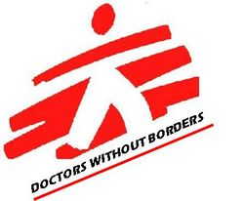

United Nations and their Organizations:

Fair Trade Logos:
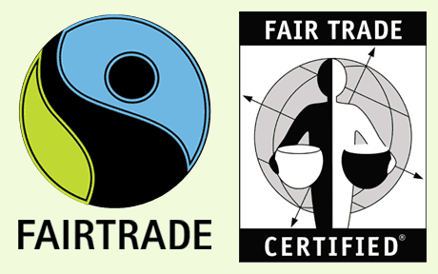

You should also check your notes to make sure you have ALL of the handouts and have completed ALL of the readings that were assigned in class.

