Of Mice and Men Test Review

- List all characters and provide 2-3 words to describe/identify them.

- Describe the Dream using specific details.

- What emotion causes Lennie to become violent? What are two examples of this happening?

- Explain the significance of the title?

- Describe Carlson’s character. What are two examples of Carlson’s insensitivity in the novel?

- Why is it possible for Candy to take part in the dream?

- What is an example of a moment when we do not feel sympathy for Curley’s wife? Why? What do we learn about her that presents her as a gullible character? What is her dream? How does this shape her actions?

- Why is it necessary for George to kill Lennie?

- List the characters that are victims in the novel and demonstrate how each one had been turned into a victim by circumstances beyond their control.

- Describe how the shooting of Candy’s dog can be a symbol for what happens to both Candy and Lennie.

- Loneliness plays an important role in “Of Mice and Men.” Which characters suffer from loneliness (be specific) and explain what it is that is missing from their lives that makes them lonely.

- Be sure you can define the following and match each character to one of the 5 types of character (George, Lennie, Candy, Curley, Curley’s wife, Carlson, Slim, Crooks)
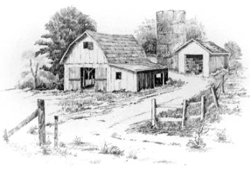
- Round character
- Dynamic character
- Static character
- Flat character
- Stock character

