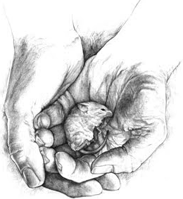
Of Mice and Men – John Steinbeck

By completing these chapter questions, you will log your understanding of the events as they occur. These questions will also be the basis for many discussions and activities surrounding Of Mice and Men. Please complete them on a separate sheet of lined paper.

Chapter 1

- Steinbeck describes the setting at length. Why does he describe so much? What is his purpose for doing so?
- Begin character sketch for Lennie and for George. Be sure to include physical descriptions, aspects of personality, and what the reader learns from one character about the other.
- How does George treat Lennie? What is their relationship?
- Why did Lennie and George get run out of town?
- What does Lennie continually ask George to tell him? What does it mean to “live off the fatta the lan”?
- Why does George push Lennie to remember the spot where they are resting?

Chapter 2

- In what ways is the dog similar to his master?
- Why does Curley dislike Lennie on sight?
- What does George tell Lennie to do if Curley comes after him?
- Complete a character sketch for Slim.
- In what clever way does George handle Curley’s wife and Curley’s questions about her?

Chapter 3

- George describes an incident in the past where George realizes that he is very much responsible for Lennie. What happened and what emotional effect did this have on George?
- In Lennie, what emotion is it that leads to violence? Give two examples of when this occurs (either in this chapter or before).
- The shooting of Candy’s dog has an emotional significance for him that goes beyond the loss of a companion of many years. Explain why.
- In your opinion, should Candy have allowed his dog to be shot? Answer in a proper opinion paragraph, providing three examples and explanations of your points.
- Slim is usually a caring and sensitive person. At one point, he says something that is unintentionally cruel. What does he say and why is it cruel?
- In the past anyone who succeeded in beating up Curley would have gotten himself “canned”. What is different about this time? Explain why Curley is willing to lie about getting his hand caught in a machine.
Chapter 4

- What is revealed by Crooks and his character about being Black?
- Discuss the theme of loneliness and its role, not only in this chapter, but in the book itself.
- What makes Lennie’s Dream so appealing to Candy and Crooks?
- Explain why Curley’s wife is “dangerous” to men in general and specifically to Crooks.

