Lord of the Flies Final Test Review
Knowledge and Understanding
- Why are the boys on the island?
- What is the political situation…Global scale?
- What is the setting?
- What leadership qualities do the boys possess?
- Describe the personality of the following characters: Ralph, Jack, Piggy, Simon, Roger, Samneric, the littluns, the hunters (who become the savages)
- What do these characters represent?
- What rules do the boys set up initially on the island?

Thinking and Inquiry
- Define the term symbol. Identify and give the significance of the conch, Piggy’s glasses, the lord of the flies, the parachutist, the fire
- Compare instances of light and dark on the island. Use your ability to describe the setting for this one.

Communication
- Be able to summarize the novel
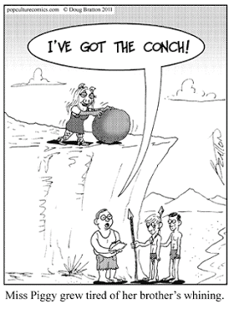
- Evaluate the effectiveness of the choices made by the characters and the consequences of these choices.

Application
- Which character do you relate to most? What would you do if you were put in a similar situation?
- Text to text comparison of good vs evil
- Identify the three types of allegory studied in class. Identify the one you think is Golding’s main allegory and explain why it is more pertinent than the other two.

