The Italian Campaign, D-Day and the Liberation of the Netherlands

Background
German troops faced __________________ in Russia. They were ___________________ to handle the ______________ Russian weather. The German army ____________________ in 1943. The Russian forces now turned their attention towards Germany. After failing in Russia, Hitler sent his forces to ______________.

The USA
- The American’s __________________ quickly after Pearl Harbor.
- The American _____________________________________ defeated the Japanese navy island by island moving closer to Japan.
- In 1942, British and American troops drove back the Italian and German forces in North Africa.
- The Canadian, British and American troops then moved to ____________ where the German troops had moved.

The Liberation of Italy
- The Italian campaign was ____________________________________.
- The German’s put up a wall of ________________________ from Rome to Ortona.
- The American, British and Canadian forces _____________________ the German’s through Italy.
- They had to _____________ through the _______________________________ and were often attacked by German ____________________ hidden in the mountains.
- It was a __________________________________________.
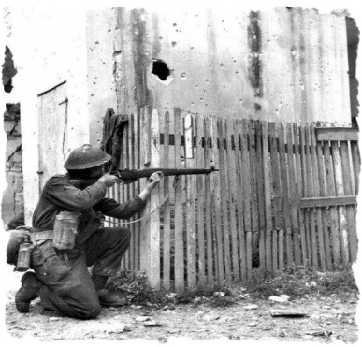
- More than ______________________ soldiers were wounded or killed.

The Invasion of Sicily
- Canadian soldiers had _______________________________ since the disastrous raid on Dieppe.
- In July 1943, Canadian’s were sent to Italy to aid in the invasion of _____________.
- This battle was fought in the hot Italian summer and lasted ___________________.
- ____________________ dream of a new Roman Empire was shattered and his own people ___________________ and through him out of power in 1943.
- Hitler swiftly moved German troops into Italy; he would not let Italy’s surrender __________________________________.

The Battle of Ortona
- It was a ________________________________ takeover.
- Canadian’s became experts at _______________________________.
- They developed the _______________________ technique.
- ____________________ Canadian soldiers lost their lives.
- On June 4, 1944, the Allied armies entered Rome to the ___________________ of the Italian people.
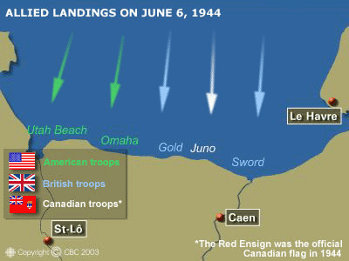
- These soldiers, in February 1945 were ________________________ to join the Canadian army fighting to free Holland from German control.

D-Day: The Beginning of the End - The Plan
- This happened on June 6, 1944
- The goal was to infiltrate ___________________________ and push the Germans back
- The official name was _________________________________

The Attack
- This was a combined Allied effort – US, British and Canadian
- This used _______________________________________________
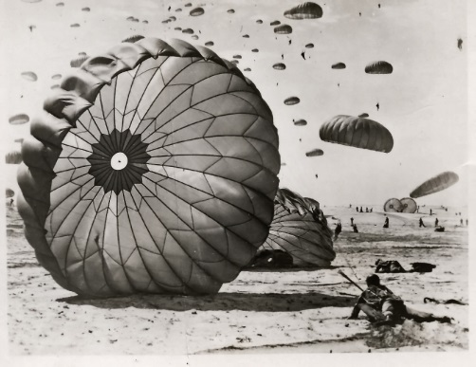
- It began with ____________________________ at 2:30 a.m. and forces started invading the beaches at 6:30

What did Canada do?
- We gave paratroopers, soldiers, over ____________________ and airplanes
- We landed at _______________________
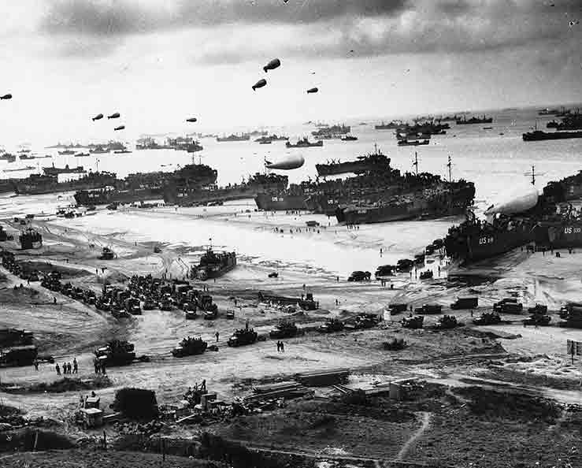
- We were the only Allied force to meet __________________ for the day – ______________________________________________

Overall Effort and Impact
- Over 156 000 Allied troops landed on D-Day
- Roughly ___________________________ were Canadian
- Within a month, ____________________________________________________________
- The _____________________________________ had begun – This was The Beginning of the End for Nazi Germany

Freeing Belgium and the Netherlands
- After the success of Normandy, in 1944, Canadian troops helped free Belgium from the Nazis, and then did the same for the Netherlands.
- The Dutch were ___________________________
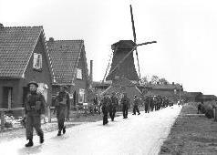
- __________________ Canadian soldiers died liberating Belgium and the Netherlands.
- The Dutch still acknowledge Canadians’ sacrifice every year by sending thousands of ______________________ to Ottawa.

