Canadians at War: Hong Kong and Dieppe

Hong Kong November/December 1941

Background:
- Hong Kong was a British ______________ and had to be protected.

The Battle:
- Canadian soldiers went to help ___________ Hong Kong on Nov 16, 1941, just in time for the outbreak of war in the Pacific.
- They joined troops from _________________________and Hong Kong. It was now truly a global war.
- On December 8, Japan attacked Hong Kong from the _______________________. They were experienced and had many resources.
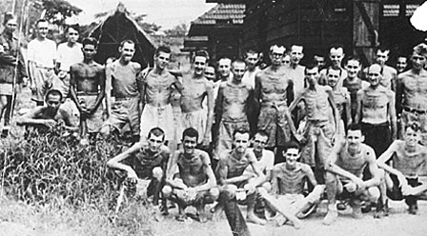
- The Canadians were relatively __________________, ______________ from ________________, and had no hope of ________________________________.

Canadian Surrender and Aftermath:
- They _____________________ on December 25th, 1941. Almost _________ Canadians had died in the __________.
- After surrender the Canadians became ________________ (POWs) for more than _______________________ years.
- In the camps they were put to____________________ and experienced poor conditions. More than _______ Canadian POWs died.
- Of the almost 2,000 Canadians who went to Hong Kong in 1941, more than 550 would never see Canada again.

Dieppe, 1942

On Aug, 19th, 1942, Canadians raided (attacked) the beaches of Dieppe.
Reasons for Attack:

Objectives of attack:

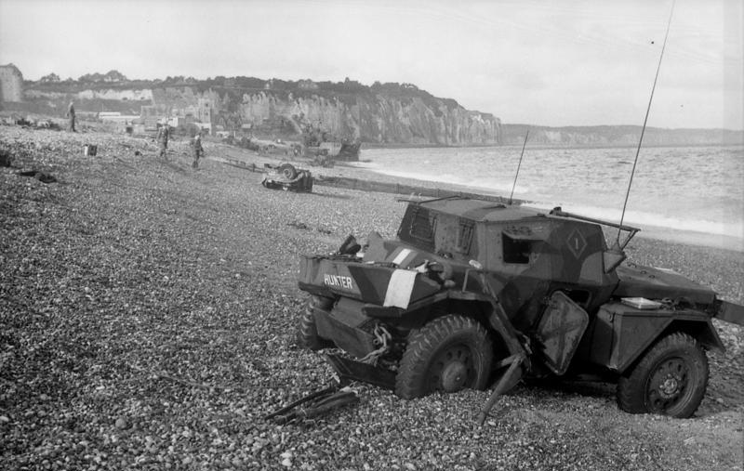
The Details:
- 6100 Allied troops depart, of which ___________ were Canadians, landed on the beaches of the French town of Dieppe.
- Unfortunately, the raid was ____________ from the start as a German envoy encountered the Allied forces as they prepared to attack.
- The German forces on the beaches were ________________ of the ________________attacks.

Problems - What Went Wrong:
- The Allies had to ___________ the landing until daylight so the elements of ____________ and darkness were lost.
- The Canadians received heavy fire from the German forces ____________ on the ___________ above the beaches.
- Tanks that were supposed to support the troops _______________________________________.
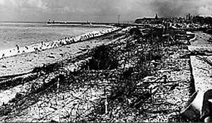
- Most soldiers tried to get back to their ships but were open ___________ for the German _________________.

Lessons Learned:
- Of the 5000 CND troops, approx. 900 were killed and another _________________________________________.
- The disaster at Dieppe raised many questions about the Allies ability to _________________________________________.
- Even today, people still wonder why the raid on Dieppe was allowed to be such a disaster.
- The Allies did learn from their mistakes and these lessons were _______________ for the planning of the _____________________.

Check In:
In Hong Kong, Canadian troops were defending a city. In Dieppe, they were attacking. How might these battles have been seen at home in Canada?

Take a look at the photos above. If you were the minister of defence in 1941, would you allow these photos to be released to the public? Explain your reasoning.

Do you think Canadian soldiers were ready to face the Japanese at Hong Kong or the Germans at Dieppe? What information can you use to support your opinion?

Consider the probability of success at Dieppe. Do you think the British sent Canadians to their death on purpose?

