Foreshadowing in Shakespeare’s Othello

Why do authors use foreshadowing?
In tragedy, when the audience does know what is coming, foreshadowing can be particularly powerful. We, as the reader or viewer, know the characters are doomed to die soon, and it makes it more poignant when the characters themselves seem to have visions of this doom.

- Foreshadowing refers to any time in a story when there is a warning or indication of things that will happen later in the story.

The Willow Song
- Originally sung by one of Desdemona’s mother’s servants who loved a crazy man.
- Reflects Desdemona’s position/situation.
- The woman in the song is worried that the man she loves has gone crazy and will abandon her.
- Willows at the edge of water are traditionally symbols of women deserted by their lovers.
{Shakespearean ex: In Hamlet, Ophelia falls out of a willow tree and drowns after Hamlet abandons her.}

Foreshadowing in Othello’s speeches

“She loved me for the dangers I had passed,/And I loved her that she did pity them.” (3.2.171 -172)

- Othello’s speech about wooing Desdemona foreshadows his suicide speech.

“Then must you speak/Of one that loved not wisely, but too well./Of one not easily jealous, but being wrought,/Perplexed in the extreme. Of one whose hand,/Like the base Indian, threw a pearl away/Richer than all his tribe. Of one whose subdued/eyes” (5.2.360-367)

- Othello’s speech about his wooing Desdemona seems romantic and beautiful at the time.
- It foreshadows trouble by emphasizing that Othello and Desdemona’s relationship is based on their differences and Othello’s exotic background.

Iago’s Role
- Iago, the master manipulator, uses this to manipulate Othello, letting him assume that these exact reasons/qualities Desdemona loved – his age, experience, foreign, exotic origin, and dark skin – are what have led her to cheat.

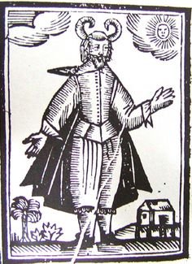

Othello’s Tragic Flaw
Jealousy

- His downfall becomes his own doing, and he is no longer, as in classical tragedy, the helpless victim of fate.

- Othello's tragic flaw was jealousy which heightened his suspicion and caused him to rush into action unchecked by rationality or common sense.

