Fairy Tale Crimes: Elements of a Crime

Name: __________________________________________

Assignment
- working in pairs or alone you will examine the offences committed in a classic fairytale (you are encouraged to be creative!)
- you must have your fairy tale choice approved by ME!
- no 2 groups may choose the same one (first come first served)
- you must present the required information in a creative way: crime report, “crime”/investigation board, other (to be approved by ME)
- you should include graphics and colour
Required
- Title of fairy tale and original author and date
- Synopsis of Fairy Tale (Summary)
- List all the parties to the offence(s) and their role in the offence(s)
- Define all the offence(s) (crimes) from this story
    - find the Offence in the CCC and define in your report
    - be sure to list the section # and definition
- List the penalties (summary and indictable) for the offences in #4 (you may choose to create a table for the information in #4 & 5)
- Provide mens rea and actus reus in your fairytale
- Based on #6 would the defendant(s) be found guilty in a court of law today? WHY?
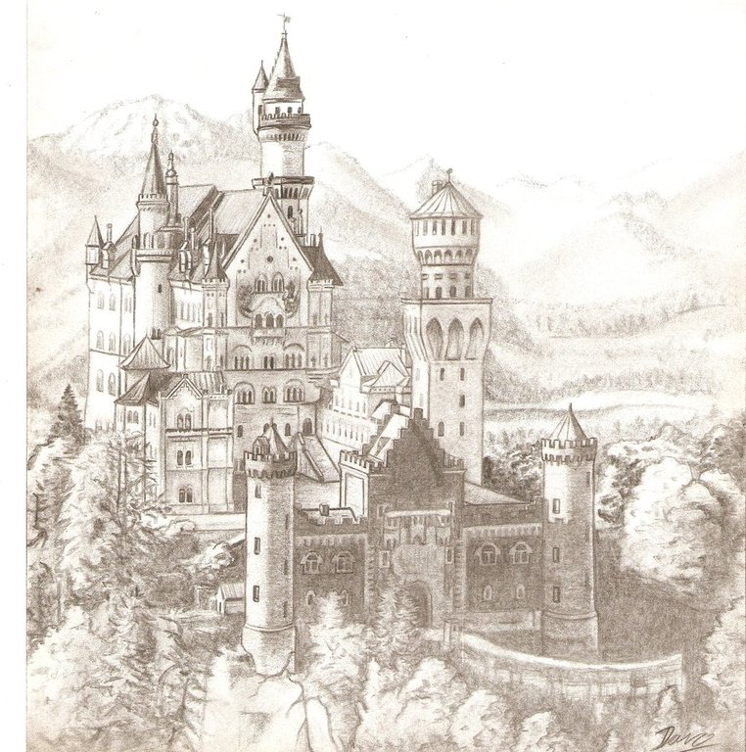
Finding Your Fairy Tale:
- There are some websites on the course website
- As well, search for:
  - Hans Christian Andersen
  - Grimm
  - the first few sites are indexes of hundreds of fairy tales

Categories | Level 1  (50 - 59%) | Level 2  (60 - 69%) | Level 3  (70 - 79%) | Level 4  (80 - 89%) | Level 4+  (90-100%)
Knowledge/Understanding  -Synopsis, parties/roles, offences, penalties, mens rea and actus reus  /10 | Demonstrates limited understanding of content. | Demonstrates some understanding of content. | Demonstrates considerable of understanding content. | Demonstrates thorough understanding of content. | Excellent understanding of content.  .
Application  /10 | Transfers knowledge of course content to contexts with limited effectiveness. | Transfers knowledge of course content to contexts with some effectiveness. | Transfers knowledge of course content to contexts with considerable effectiveness. | Transfers knowledge of course content to contexts with a high degree of effectiveness. | Transfers knowledge of course content to context with a high degree of effectiveness
ANALYSIS  -verdict in today’s court of law, identification of offences within chosen fairy tale  /10 | misses or inaccurately identifies offences(s); verdict is not justified | Identifies some offences within fairy tale, but misses or inaccurately identifies other(s); verdict is not entirely justified | Accurately identifies offences within fairy tale; verdict is not entirely justified | Accurately identifies offences within fairy tale; verdict is well-supported | Accurately identifies offences within fairy tale; verdict is well-supported; ample evidence provided
COMMUNICATION  /10 | Little or no effort into presenting the content in a creative manner; many spelling and grammar errors.  Content is missing, is not clearly communicated and project is difficult to read/understand. | Little effort into presenting the content in a creative manner; many spelling and grammar errors.  Content is not clearly communicated and is disorganized. | Some effort into presenting the content in a creative manner; some spelling and grammar errors.  Content is fairly clearly communicated and information is mostly easy to find. | Content is presented in a creative way; good spelling and grammar  Content is clearly communicated and well-organized. | Content is presented in a highly creative way; excellent spelling and grammar  Content is clearly communicated and well-organized.

