ENG4C Character Analysis Assignment
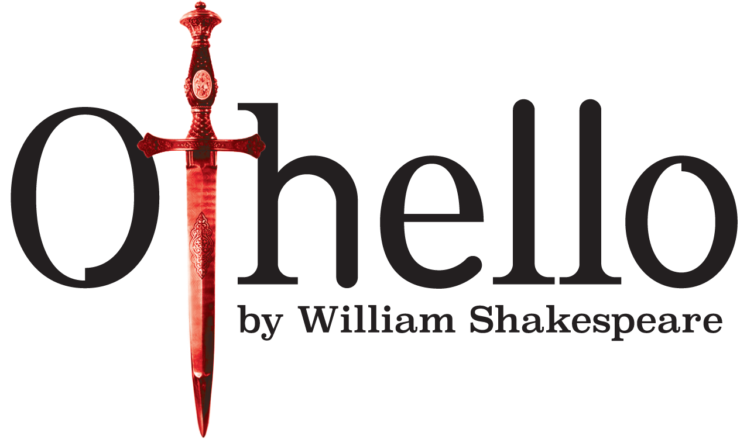

Character traits are individual aspects of personality. Othello consists of a variety of characters that possess various types of personality traits. Your task is to create a profile of a character from Othello with the framework provided below.

Your character choices (choose ONE/1):

Desdemona Iago Michael Cassio
Rodrigo Othello Emilia

Your Character Profile must include:

- Name of character
- 4 Personality traits
- 4 quotations that support your character’s traits (with page numbers).
Use the following link to access Othello online: http://www.sparknotes.com/shakespeare/othello/
- An image of your character as you might perceive them (can be a celebrity, politician, etc.).

A typed Character Analysis that answers the following questions:

- What are your character's motives? Why?
- How does the character perceive him/herself? How do others perceive this character? Explain.
- Does your character change significantly during the course of the play? Explain your reasoning.

Your typed analysis is to be stapled to the back of your character profile (Min 350 words).

Evaluation: /30 Marks

EXAMPLE

Your Name:
Date:

Quotation 02

Quotation 01

Trait 02
Trait 01

CHARACTER NAME

(Image)

Quotation 03

Quotation 04
Trait 03
Trait 03

