Customer Etiquette – How to Deal with a Bad Review

Learning Goal: I will examine different ways to respond to bad reviews and develop diplomatic responses.

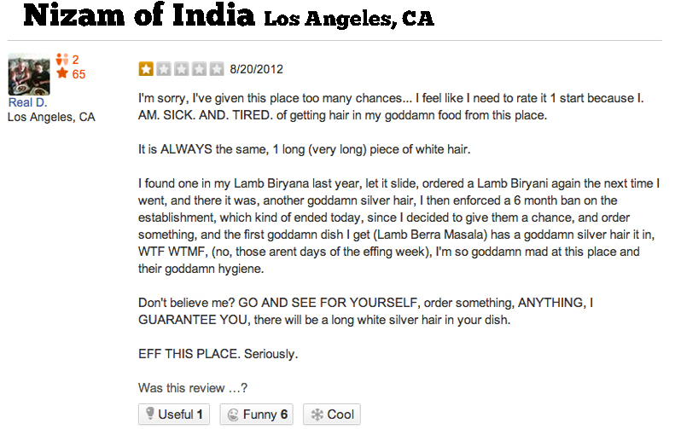
Imagine you own the restaurant Nizam of India. With a partner, you will first discuss, after a 12 hour day at work, how you would like to respond followed by how you should respond. You will then write a properly formatted and diplomatic response following the format discussed. Be prepared to share with the class.
____________________________________________________________________________________________________________________________________________________________________________________________________________________________________________________________________________________________________________________________________________________________________________________________________________________________________________________________________________________________________________________________________________________________________________________________________________________________________________________________________________________________________________________________________________________________________________________________________________

