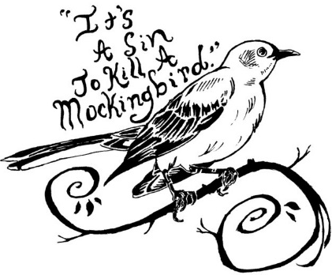
ESSAY PLANNING SHEET

TITLE Example:

Significant Quotation: |  |  |  | From a Different Perspective:
Topic: |  |  |  | The Importance of Empathy
 | in |  |  | In
Author: |  | Title: |  | Harper Lee’s To Kill a Mockingbird

INTRODUCTORY PARAGRAPH

WORDS OF INTRODUCTION
- a few sentences talking about your essay topic in a general way
- this could be a place to define your terms, discuss issues brought up by your epigraph, et cetera
- do not discuss the book or the author in this section!
THESIS
- the single most important sentence in your essay!
- make sure it is an argument!
- use the KISS rule (“Keep it simple, stupid!”); additional info can be supplied by the elaboration
- make sure it does not just say “Topic X exists in the story”
- mention the story and the author (e.g. – “In Edgar Allan Poe’s ‘The Tell-Tale Heart’…”)

ELABORATION
- a sentence or two expanding on your thesis
- it could serve to delineate the boundaries of your argument
PLAN OF DEVELOPMENT
- a sentence outlining the content of your body paragraphs
- should be in order! (e.g. – the first point mentioned in the plan should be the topic of the first paragraph, the second point the second paragraph, and so on)

CONCLUDING PARAGRAPH

THESIS RESTATED
- literally a rewrite of your thesis statement from your introductory paragraph
EXAMPLES SUMMARIZED
- a rewrite of your plan of development from your introductory paragraph
- often includes a bit more detail from your body paragraphs than your plan of development did
WORDS OF CONCLUSION
- a few sentences that tie up your thesis nicely
- often a good place to work in a mention of your title quotation!

 | BODY PARAGRAPH #1 – should be your second-strongest set of arguments | BODY PARAGRAPH #2 – should be your third-strongest set of arguments | BODY PARAGRAPH #3 – should be your strongest set of arguments

TOPIC SENTENCE
- a simple sentence stating what your paragraph will be about
- like your essay’s thesis, follow the KISS rule for this sentence

ELABORATION
- a sentence expanding in some way on your topic sentence
- some students use this sentence as a “mini-plan of development” for the paragraph

EXAMPLE #1
- this sentence must contain a quotation from the literary work (do not forget citation – page number, line number, et cetera)
- the quotation should be blended into your sentence
- remember: the quotation by itself is not the sentence!
- example #1 is usually your second-best proof

ANALYSIS #1
- this sentence explains how the first quotation proves the thesis
- this sentence analyzes the relevance of the first quotation

EXAMPLE #2
- this sentence must contain a quotation from the literary work (do not forget citation – page number, line number, et cetera)
- the quotation should be blended into your sentence
- remember: the quotation by itself is not the sentence!
- example #2 is usually your third-best proof

ANALYSIS #2
- this sentence explains how the second quotation proves the thesis
- this sentence analyzes the relevance of the second quotation

EXAMPLE #3
- this sentence must contain a quotation from the literary work (do not forget citation – page number, line number, et cetera)
- the quotation should be blended into your sentence
- remember: the quotation by itself is not the sentence!
- example #3 is usually your best proof

ANALYSIS #3
- this sentence explains how the third quotation proves the thesis
- this sentence analyzes the relevance of the third quotation
CONCLUDING SENTENCE
- this sentence wraps up the paragraph
- often a simple re-wording of the topic sentence

ESSAY PLANNING SHEET

THESIS:

