Civics - The Canadian Charter of Rights and Freedoms

What is it?
The Charter is founded on the rule of law and entrenches in the Constitution of Canada of 1982 the rights and freedoms Canadians believe are necessary in a free and democratic society.

Guarantee of Rights and Freedoms
- The Canadian Charter of Rights and Freedoms guarantees the rights and freedoms set out in it subject only to such reasonable limits (reasonable limits clause) prescribed by law as can be demonstrably justified in a free and democratic society.

Fundamental Rights
Everyone has the following fundamental freedoms:
- freedom of conscience and religion;
- freedom of thought, belief, opinion and expression, including freedom of the press and other media of communication;
- freedom of peaceful assembly; and
- freedom of association.

Democratic Rights
- The right of citizens to vote (even if you are in jail) and to run as a candidate in a municipal, provincial, or federal election

Mobility Rights
The right of citizens to enter or leave Canada and to live and work where they choose

Legal Rights
- Right to a safe life, humane treatment, a fair trial if one is accused of a crime, and option to take an issue in court

Language Rights
- The right to use either English or French when communicating with the government or in court, and to be educated in either language when there is sufficient number of students

Aboriginal Rights
- the protection of Aboriginal, treaty, or other rights or freedoms that pertain to Aboriginal peoples of Canada
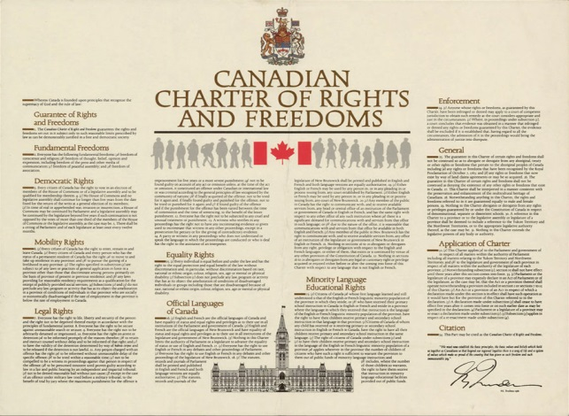

Constitution Act, 1982
http://laws-lois.justice.gc.ca/eng/Const/page-15.html

