Brooklyn Media Unit
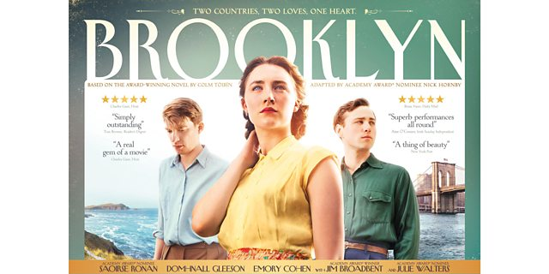

Monday | Tuesday | Wednesday | Thursday | Friday
9  Examine expectations in preparation for this very short unit.  Watch and discuss the film Brooklyn | 10  Watch and discuss the film Brooklyn | 11  Watch and discuss the film Brooklyn  Time to work on your essay  Miss Neals will hopefully be back!!! | 12  Essay Work Period | 13(beware!)  Essay Work Period
Your essay is due Wednesday, January 18th!

Response Journal Suggestions
Response Journal collection will be on Thursday, January 12th 2017.

- What kind of person is Eilis at the beginning of the film? What challenges might she have faced up to this point in her life? What decision would you make? Would you leave your family to pursue a new life or would you stay?

- Consider the challenges one faces when leaving home. Compare the sacrifices Eilis must make to that of a student going off to university or a family member moving away for a job in today’s society.

- Imagine Eilis in today’s world. Do you see her primarily as a career-motivated woman, or as a wife and mother? How is the conflict between job and family presented in the 1950s? How is it different today?
- Something happens to Rose that, in retrospect, makes you re-examine the reasons she might have urged Eilis to move to America. Discuss this.
- Do you think Eilis wanted to marry Tony? What pressure was on her to marry him? What would you have changed about her actions here?
- Eilis decides to keep her marriage to Tony a secret from her mother and friends in Enniscorthy because she believes they won’t understand. Do you believe that this is Eilis’s true reason, or might her silence indicate other motives?
- Does Eilis’s notion of her duty to family evolve from the beginning of the novel—when she leaves Enniscorthy—to the end, when she returns to Tony in America?
- If Eilis had been able to choose freely, between Brooklyn and Tony, and Enniscorthy and Jim, what do you think she would have chosen? Or is Eilis really a young woman who does not choose, who allows others to determine her fate?
- Toibin ends the novel Brooklyn before Eilis even boards the ship back to America, leaving her future unwritten. Why do you think Toibin chose to end the book there? Why do you think film writers decided to end the film with more solidity to Eilis’ future?
- What is most irritating about Eilis? What is most endearing?
Essay Summative Task
The summative for this unit is a literary essay. Below are the questions you may choose from. This is not a comparative essay as done previously and will be you culminating assignment.

Essay questions:
- Discuss the nature of personal freedom in relation to Brooklyn.
- Eilis’ transformation is ultimately in vain. Agree or disagree.
- Loneliness and isolation that afflicts Eilis is shown as the typical product of modern life. Discuss.
- A topic of your choosing that must be approved!

STEPS TO FOLLOW

PLAN
- Choose a TOPIC, and then a POSITION on the topic (what is your argument?)
- Draft a SENTENCE (THESIS) stating your position.
- List (at least) three points that support your position.
- In point form, outline an explanation and/or example for each point.
- Organize your points. Place your strongest point last unless working through the chronological structure.
- Find textual evidence to support each point.

WRITE
- Write the body of your opinion piece. State each point, providing explanations and examples for each. Examine each quotation and elaborate on the significance of elements such as diction and rhetorical devices. Always PEE! (Point, Evidence, Explain)
- Write an introduction. Write a lead (opening sentence) to grab the reader’s attention. Include a sentence that states your position (thesis).
- Write a conclusion: restate your position in different words, and draw a conclusion about the ideas you proposed in your thesis and what can be learned from the exploration of this topic.

REVIEW
- Correct: Make sure each sentence is clear, and there are no spelling or grammar mistakes.
- Review: Ask yourself, “Does each paragraph develop and support my thesis statement?

NOTE: ABSOLUTELY NO SECONDARY SOURCES ARE ALLOWED. Do not access the internet for any reason at all. Plagiarism is a slippery slope….

The bulk of the work is to be done at home, but you will have some time to write in class. You must submit the attached rubric and your planning sheets with your essay.

