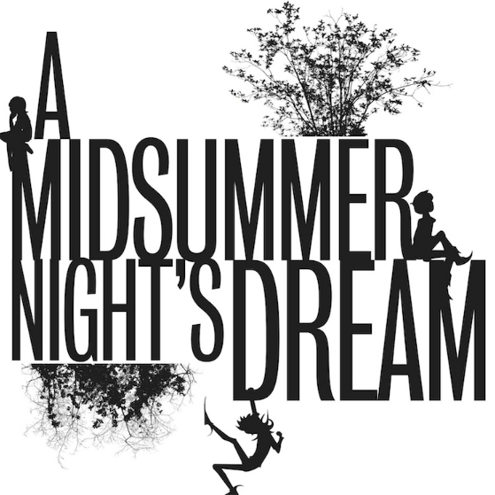

28  Intro to AMND  Finish Presentations | 29  More intro and Shakespearean Insults, Pyramus and Thisbe, Read I,i | 30  Magical Forest Creation (Character sketch)  Read I,ii | 1  Read II, i-ii | 2  ISU DAY
5  Character/terms Quiz and ISU DAY | 6  Read Act III, i | 7  Read Act III, ii | 8  Read Act IV, i-ii | 9  Read Act V
12  ISU DAY | 13  Analysis | 14  Analysis | 15  AMND Test Review | 16 AMND Final Test
19  ISU DAY | 20  Poetry | 21  Poetry | 22  Poetry | PA DAY  Merry Christmas and Happy Holidays!
