A Letter from the Trenches
Learning Goal: By writing a letter from the trenches, I will communicate terms and historical events learned in class in a creative way.
Imagine you are a young Canadian soldier sent to fight on the Western Front during World War One. Describe your experiences in the trenches in a letter to someone you miss back home in Lindsay.
You must:
- Write your letter in first person
- Include information from one of the major battles we studied in class
- Include information about the technology used.
- Include information about the horrors soldiers faced.
You should include all of the following words in your letter. Tick them off as you use them.
- Trench
- Dug out
- No Man’s Land
- Barbed Wire
- Mud
- Machine Gun (Lewis, Vickers)
- Lice
- Rats
- Smell
- Gas
- Gas mask
- Rifle (Ross Rifle, Lee Enfield)
- Soldier
- Rations
- Bombing
- Trench Foot
- Sitting Duck
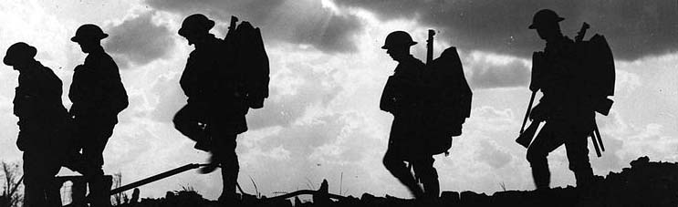
Phrases that you could adopt for your own use:

“I will never forget these terrible conditions…”

“It was so horrible. I can hardly bring myself to write about it…”

“So many innocent lives have been lost…”

“I am so lucky to have survived so far! I will never forget those who died fighting alongside me…”

“The trench is horrible, but it gives us somewhere to rest…”
Vocabulary that may be useful…You could look up meaning in a dictionary if you need!

Awful Onslaught Hunger
Barbarous Stench Decaying
Gruesome Petrified Boredom
Horrendous Disease Hopeless
Horrific Blighty Stale
Terrible Squalid Torture

